Royal Albert Hall
Access Guide

We want to make sure everyone has a safe, enjoyable, and inclusive experience at the Royal Albert Hall.
This guide provides information on our access services and facilities. It also provides our contact details if you need more information.

Contents
Booking 2
Transport 3
Getting Around 7
Building Overview 9
Services and Facilities 22
Food and Drink 27
Daytime Visits 29

Booking Information

To book accessible tickets, please call the Box Office on 020 7589 8212 or visit our booking desk located at Door 12 of the building. Our phone room is open Monday – Friday 9am – 5pm and in-person booking desks are usually open daily from 9am-9pm.

A free companion ticket is available for disabled people who require an assistant companion (limited availability).

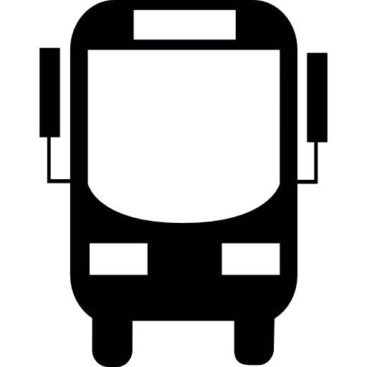

Transport

Blue Badge Holder Car Parking Spaces
For customers attending events in our auditorium there are usually ten free parking spaces for Blue Badge holders at 1851 Place. The entrance is located outside Door 8, which has ramped access to the building. To book a space, please email: accessbooking@royalalberthall.com

Please include your vehicle registration number. On rare occasions we may not be able to offer any Blue Badge parking due to event requirements. Information about roadside Blue Badge parking bays can be found on the Westminster City Council website.

General Parking
General parking is also available at Imperial College campus, a five-minute walk away (SW7 2BX). Entrances are located on Exhibition Road and Prince Consort Road (evenings only). Spaces cost £11 (including fees) and can be booked through our website here.

On-Street Parking
Strict parking controls are in operation on all public roads around the Hall. There is one parking bay outside Door 1 of the Hall, which has been allocated solely for use by Blue and White Badge holders. Further Blue Badge bays are located outside the museums on Exhibition Road. There is Pay-and-Display on-street parking on Prince Consort Road and Exhibition Road.

Arrival and Setting-Down Points
For arrival by car, taxi, minibus or Dial-a-Ride, the most convenient set-down point outside the Albert Mansions on Kensington Gore.

For customers using the Royal Albert Hall car park, the nearest entrance is Door 8, which has ramped access and usually opens two hours before the start of the performance.
Underground
South Kensington (District, Circle and Piccadilly Lines) and High Street Kensington (District and Circle Lines) are the closest underground stations to the Hall. Neither of these stations are wheelchair-accessible. Walking to the Hall takes approximately 10 minutes from both stations.

The closest step-free underground station is Green Park, from there you can take the number 9 bus to the Royal Albert Hall.
If you are using public transport, we recommend checking TFL to find the best route.

Buses
The following buses stop on Kensington Gore outside the Hall:
9: Aldwych to Hammersmith, stopping on Kensington Gore outside the Hall
23: Westbourne Park to Hammersmith, stopping on Kensington Gore outside the Hall
52: Victoria to Willesden, stopping on Kensington Gore outside the Hall
70: Acton to South Kensington, stopping on Queen’s Gate, two minutes’ walk from the Hall 5
360: Elephant & Castle to the Hall, stopping on Prince Consort Road, 1 minute walk from the Hall
452: Wandsworth Road Station to Kensal Rise, stopping on Kensington Gore outside the Hall

The following night buses also stop on Kensington Gore outside the Hall:
N9: Aldwych to Heathrow
N52: Victoria to Willesden
For further information on the Underground or buses, telephone Transport for London’s travel information line on 020 7222 1234 or visit the TFL website.

Taxis from the Royal Albert Hall
For arrival by car, taxi, minibus or Dial-a-Ride, the most convenient set-down point is outside the Albert Mansions on Kensington Gore. Vehicles can also pull up next to the South Steps on Prince Consort Road.

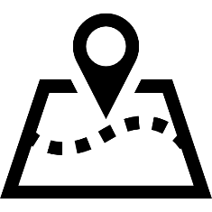
Getting Around

The Royal Albert Hall has many entrances at Ground level. Ramped access is located at Doors 1, 3, 8, 9 and 12.

Lifts
Public lifts are located at Doors 1 and 8 with automatic doors, braille, tactile numbering, and voice announcements. These lifts serve all levels from Basement to Gallery. Arena Foyers can be accessed via a platform lift from Basement level at Door 1.

Mobility Scooters
The corridors of the Hall are narrow and can become quite congested. To avoid accidents, we therefore ask that, if possible, powered mobility scooters are parked in one of our larger entrances at doors 1, 3, 4, 8 or 9.

If you choose to remain in your scooter please take care to drive responsibly and slowly and be mindful of the safety of others.

Wheelchairs
Our Stewards can provide a wheelchair to assist you around the Hall and to your seat.

We offer a wheelchair loan service. Wheelchairs can be reserved by emailing: accessbooking@royalalberthall.com.
Alternatively, you can request a wheelchair on arrival from our Stewards, subject to availability.

We are unable to offer a pushing service and customers are advised to ensure they attend with someone who can assist them if required.

Building Overview

The Royal Albert Hall is a large building in the style of a Roman amphitheatre. The seating configuration may change for different performances and some areas may not be available for certain events. Please use the maps below as a guide:

Level -1

Arena
The Arena is not accessible to wheelchair users. Entry to the Arena is from the Arena Foyer level, which can be accessed from the main stairs or via the lift at Door 1.

There are 11 steps, with handrails on both sides, from the Foyer corridor up to each Arena entrance.

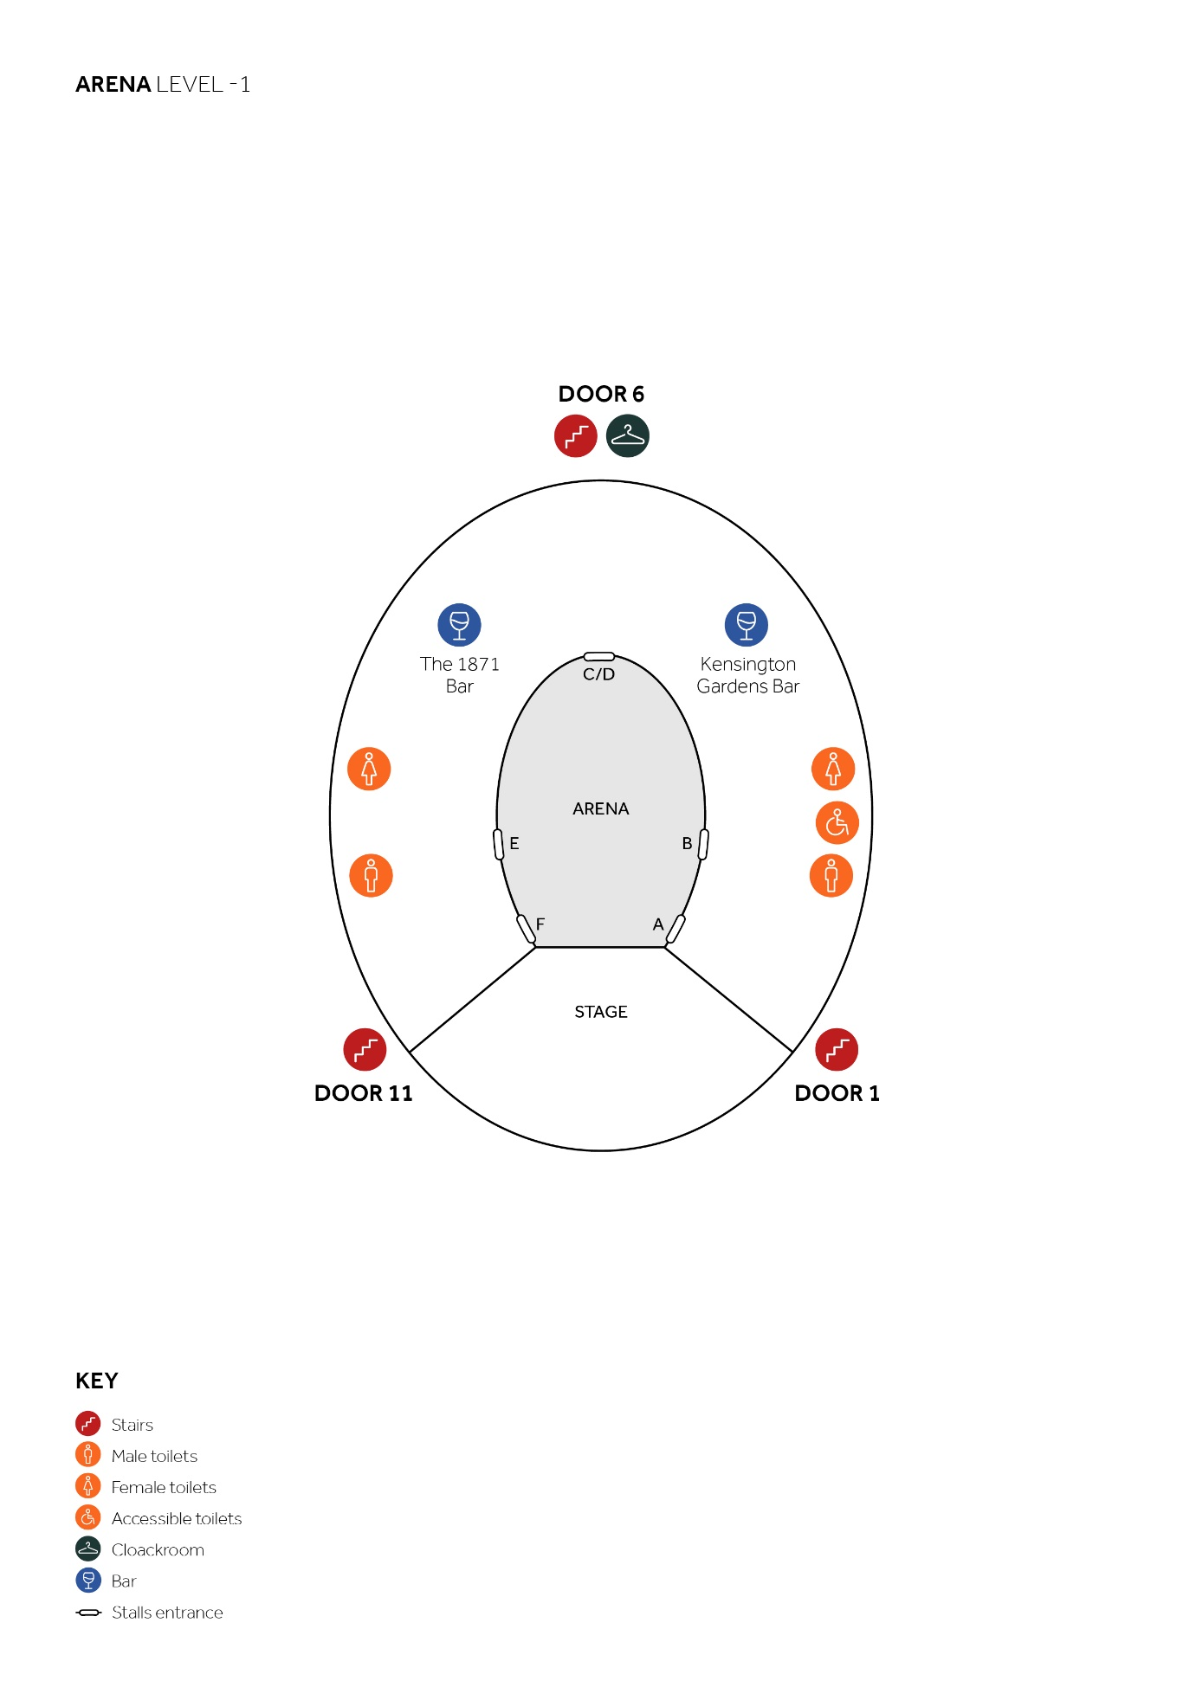
Ground Floor

Stalls
From the Ground floor there is level access to all wheelchair spaces at the back of the Stalls. The back row of seating (Row 11) is one step down and there are 21 steps down to Row 1 at the front. Stepped aisles are provided with support rails at the entry to each row of seats.

Loggia Boxes
The Loggia Boxes are not accessible to wheelchair users. From Ground level there are five steps up to the Loggia Boxes. Each box is on a split level with two steps down to the back row of seating and one further step to the front row.

The Choirs
The Choirs are not accessible to wheelchair users. Choir East and Choir West are situated behind the stage, separated by the organ, and are accessed from Ground level near Doors 1 and 11 respectively.

On each side there are eight steps up and two steps down to the front row (Row 1) and there are 24 steps up to the back row (Row 9).

While Door 1 is the main Choir access, rows 4-8 can also be accessed from the Grand Tier level and row 9 can be accessed from Second Tier level.

The Choir seats have a relatively steep gradient. The steps have a handrail on one side and support rails on the other, at the entry to each row of seats.

Row 9 can also be accessed directly from the Second Tier with just two steps down.

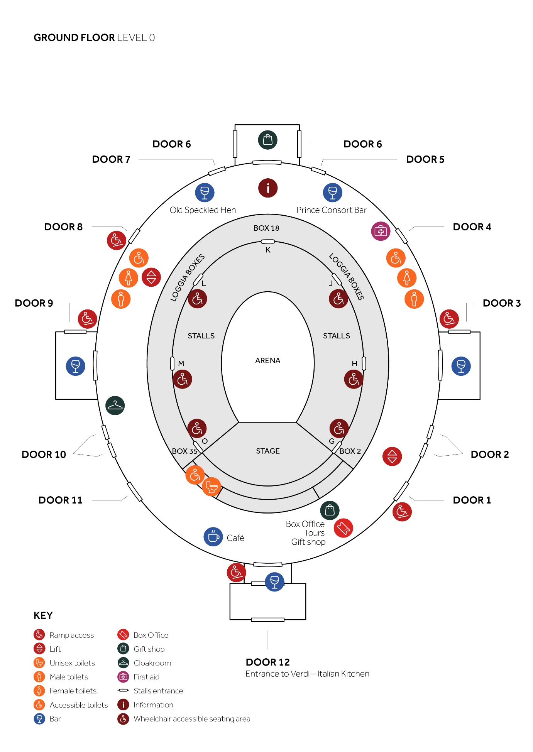

Level 1

Grand Tier
All Grand Tier seats are in boxes, which can be accessed via the public lifts at Doors 1 and 8.

Box doors on the Grand Tier are generally between 66cm–71cm wide but a limited number have widths up to 140cm. The seating is split level, with a total of four steps in each Grand Tier box.
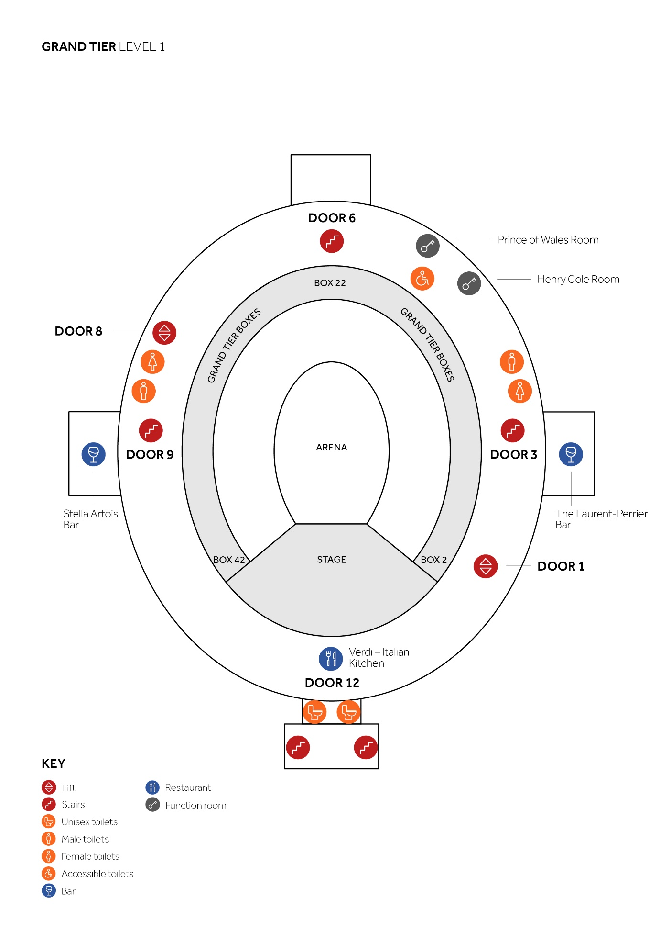

Level 2

Second Tier
All Second Tier seats are in boxes which can be accessed via the public lifts at Doors 1 and 8.

Box doors on the Second Tier are generally between 66cm–71cm wide but a limited number have widths up to 140cm. The seating is split level, with one step in each Second Tier box.

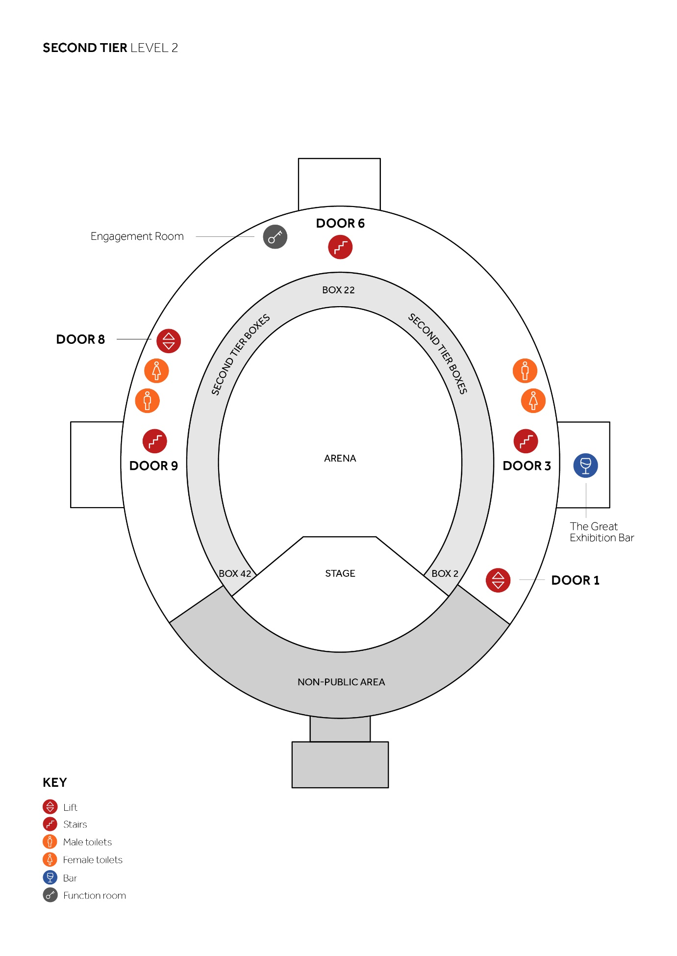

Level 3

Rausing Circle
The Rausing Circle can be accessed via the public lifts at Doors 1 and 8. There is level access to the six wheelchair spaces in the Rausing Circle. The front row (Row 1) is one step up and there are 21 steps up to the back row (Row 7).

The Rausing Circle seating has a steep gradient and all stepped aisles are provided with support rails at the entry to each row of seats.

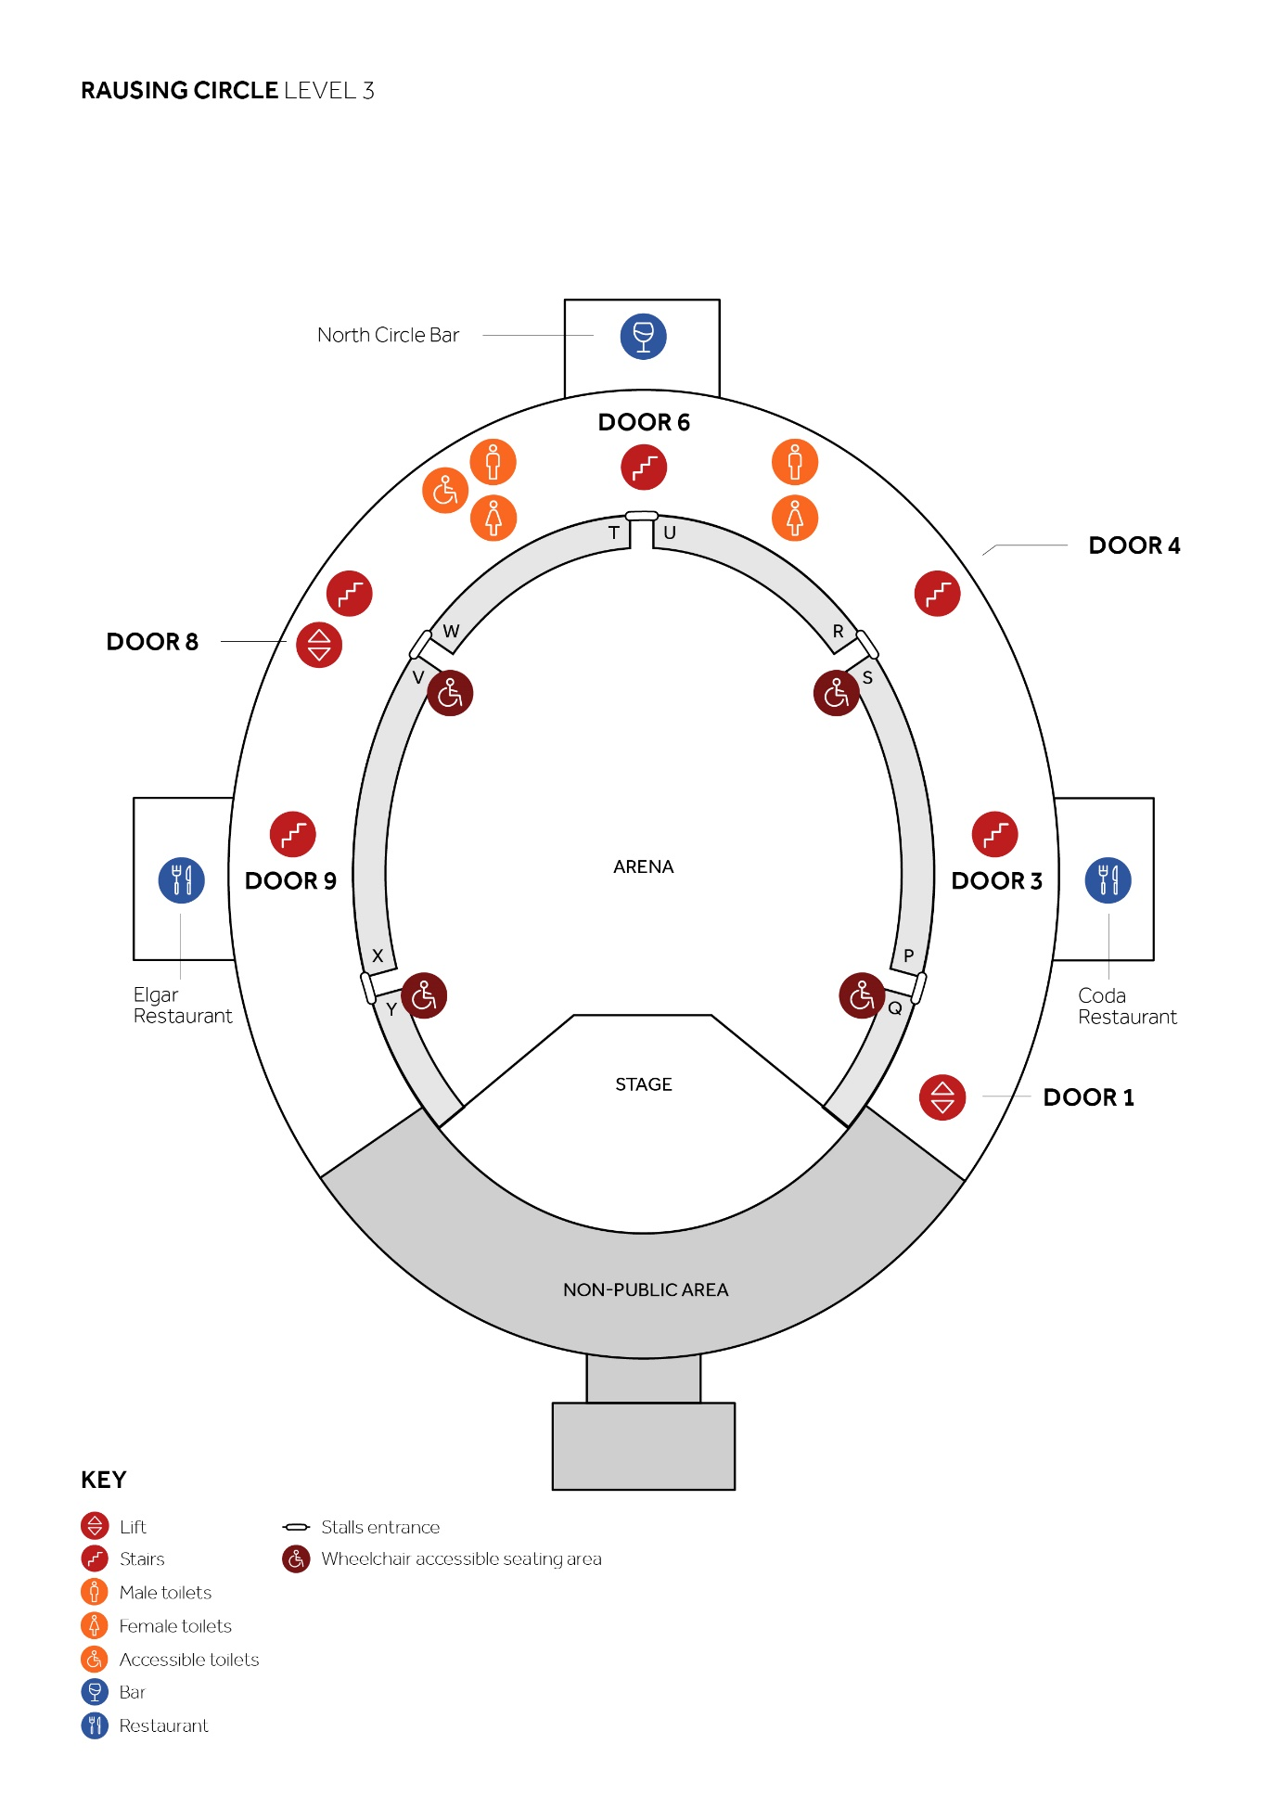

Level 5

Gallery

The standing area of the Gallery can be accessed via the lifts at Doors 1 and 8.

There is level access throughout the Gallery including a unisex accessible toilet near to Door 1 lifts.

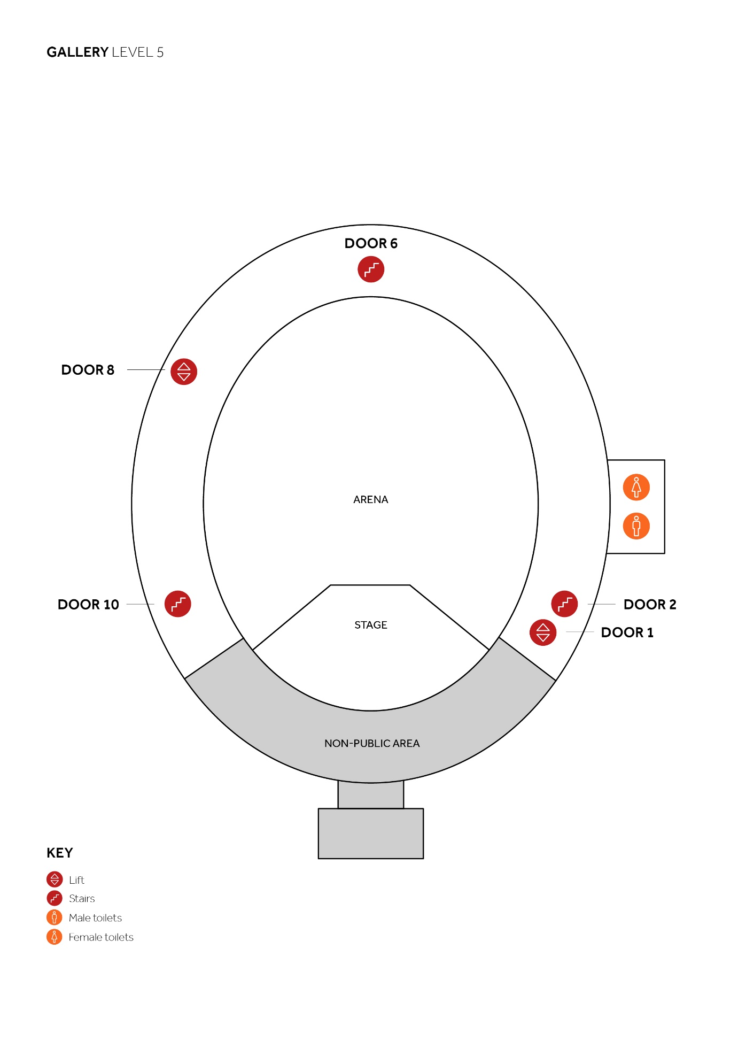

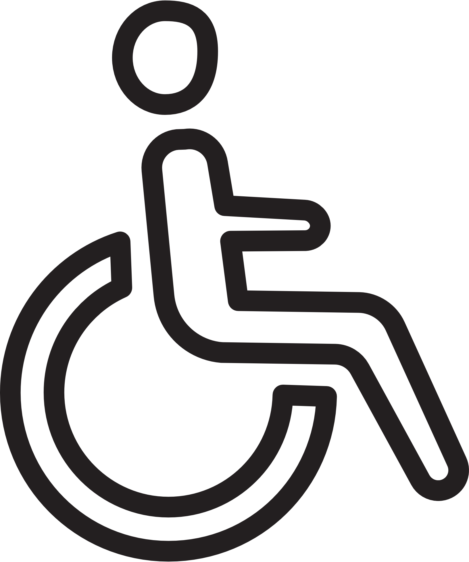
Services and Facilities

Wheelchair Spaces

Eight wheelchair spaces with adjacent companion spaces are situated in the Stalls at Ground level. In addition, there are six wheelchair spaces with adjacent companion spaces in the Rausing Circle at sections P/Q, R/S, V/W and X/Y.

Please note that due to the physical limitations of the circular shape of the auditorium, the spaces in the Rausing Circle are more suitable for customers with good upper body mobility. There are also four wheelchair spaces within the standing area of the Gallery.

We have a limited number of pre-cleaned wheelchairs for customers’ use, subject to availability. These can be reserved in advance by emailing: accessbooking@royalalberthall.com. Alternatively you can request one on arrival from our Stewards, subject to availability.

We are unable to offer a pushing service at the present time and customers are advised to ensure they have assistance if required.
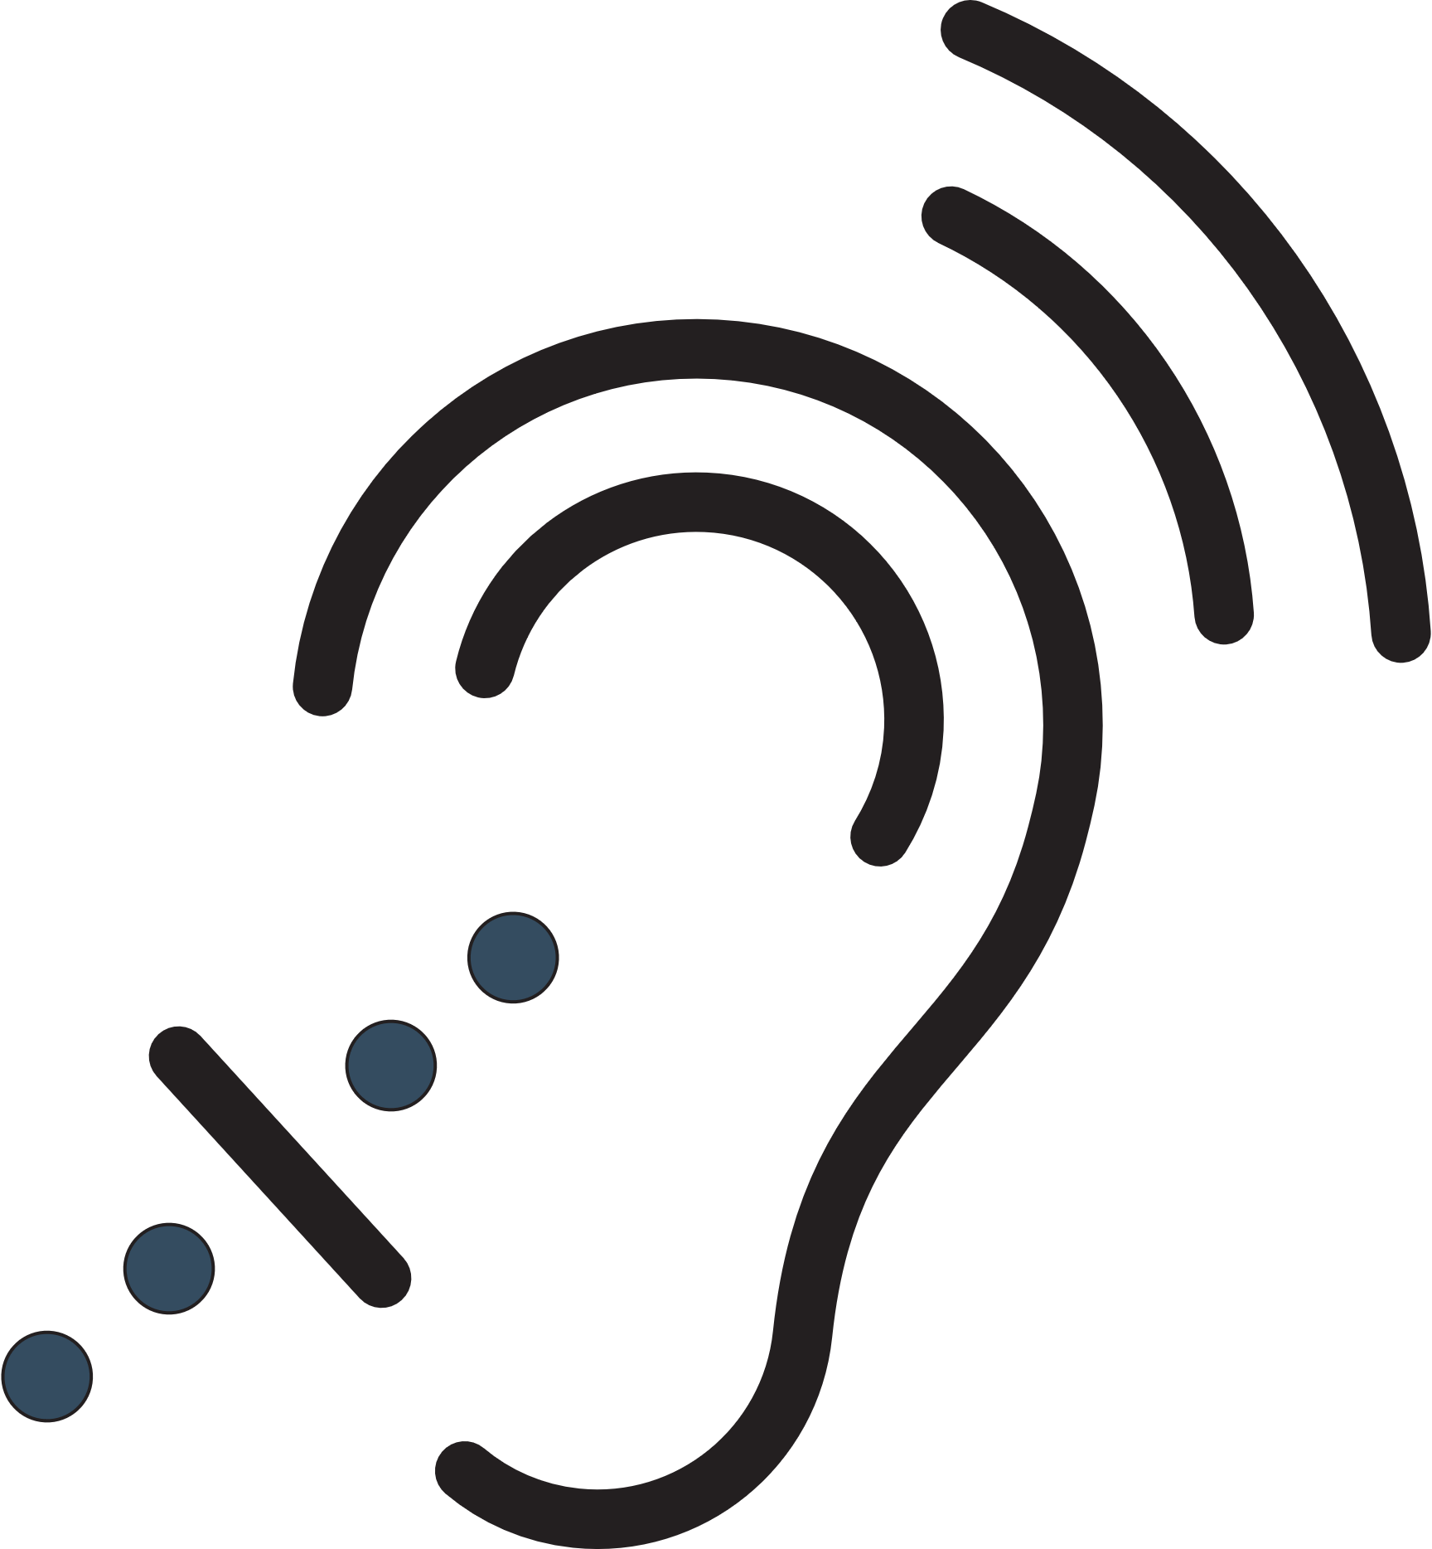

Assisted Hearing Facilities

The auditorium, Elgar Room and North Circle Bar all have an infra-red system with a number of pre-cleaned personal headsets for use with or without hearing aids.

To make use of this service, please request a headset by calling 02075898212 or by emailing: accessbooking@royalalberthall.com

Please collect your pre-cleaned headset on arrival from the Information Desk at Door 6 on the Ground floor. Please note that there is no loop system in the auditorium. The Box Office has an induction loop system. You can use this by adjusting your hearing aid to the ‘T’ setting.

Assistance Dogs

Assistance Dogs are welcome at the Hall. Please let us know when you are booking your tickets so that we can offer appropriate box seating where your dog can remain with you during the performance.

If you prefer, or if you are sitting in an area which is unsuitable for dogs, you may leave your dog with a Steward until the end of the performance. To make this request please email:
accessbooking@royalalberthall.com

Assistance dogs should be highly trained which means they:
- Will not wander freely around the premises
- Will sit or lie quietly on the floor next to their owner
- Are unlikely to foul in a public place
- Are recognisable as assistance dogs in their harness

In case of an emergency, please leave the building under the direction of the Stewards. You will be directed to an Assembly Point where we will reunite you with your dog.

Toilets

Unisex wheelchair-accessible toilets are located as follows:
- Level -1: Door 1
- Ground Floor: Door 4 porch, Door 8 porch and Door 12
- Level 1: Door 4
- Level 2: Door 8
- Level 3: Door 8
- Level 5: Door 1

The accessible toilet at Gallery level is 48cm high and all the others are 45cm high.

Cloakrooms

Our cloakroom is only available prior to a main auditorium event and you can leave your belongings in our cloakroom if you wish, at a cost of £1 per item.

First Aid

Our stewards are located throughout the Hall if you require assistance. The First Aid Room is staffed by qualified medical personnel and is located on the Ground Floor at Door 4.

Evacuation and Refuge Points

Refuge points for customers with limited mobility are located throughout the building. In the event of an emergency evacuation, Stewards will escort you to the nearest available refuge point before assisting you out of the building.

Food and Drink

The Hall has four restaurants which cater for a variety of tastes and are all accessible to wheelchair users.

- Café Bar: Ground Floor, Door 12.
- Verdi Italian Kitchen: Level 1, Door 12 stairs. Wheelchair access via Door 1 lift.
- Elgar Room: Rausing Circle level, Door 8 lift or stairs.
- Coda: Rausing Circle level, Door 1 lift or Door 2 stairs.

There are also wheelchair-accessible bars on every level, except the Gallery. For more information and to reserve a table click here.

Please note that deposits will be taken to secure your booking. Walk-ins are also available.

Box Catering

If you have tickets in the Grand Tier, Second Tier or Loggia seating areas you will be sitting in a box, and can order food and drink to be delivered directly to it.

Orders can be placed up to 48 hours before the event starts. Please book your box catering here in advance.

We have a limited in-box dining menu available on the day for most shows, which can be viewed here and ordered directly from your host.

Daytime Visits

Tours

Our guided tours offer the inside story of the Royal Albert Hall, taking you on a fascinating journey through its unique history, incredible architecture, and unparalleled performances.

All tour routes cover a moderate distance and involve stairs. Lifts are available and all tour routes are accessible to wheelchair users. To book, please email:
tours@royalalberthall.com

Tours depart from inside Door 12 and last for approximately one hour.

Café Bar

Our Café Bar, offering coffee and a selection of light meals, is open daily. The entrance is on Ground level via Door 12.

